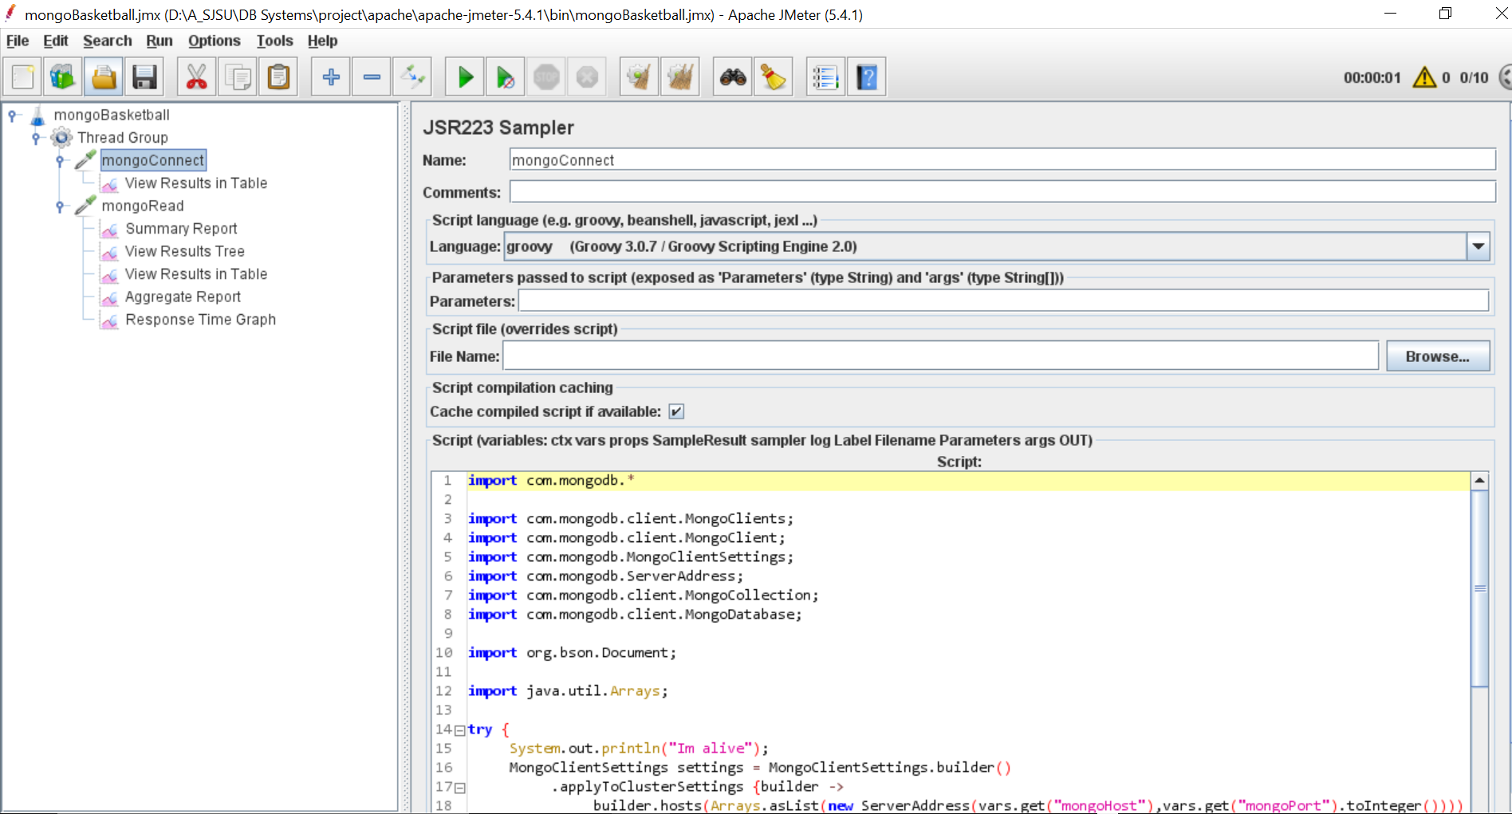

import com.mongodb.*

import com.mongodb.client.MongoClients;

import com.mongodb.client.MongoClient;

import com.mongodb.MongoClientSettings;

import com.mongodb.ServerAddress;

import com.mongodb.client.MongoCollection;

import com.mongodb.client.MongoDatabase;

import org.bson.Document;

import java.util.Arrays;

try {

System.out.println("Im alive");

MongoClientSettings settings = MongoClientSettings.builder()

.applyToClusterSettings {builder ->

builder.hosts(Arrays.asList(new ServerAddress(vars.get("mongoHost"),vars.get("mongoPort").toInteger())))}

.build();

MongoClient mongoClient = MongoClients.create(settings);

MongoDatabase database = mongoClient.getDatabase(vars.get("databaseName"));

MongoCollection<Document> collection = database.getCollection(vars.get("collectionName"));

vars.putObject("collection", collection);

return "Connected to " + vars.get("collectionName");

}

catch (Exception e) {

SampleResult.setSuccessful(false);

SampleResult.setResponseCode("500");

SampleResult.setResponseMessage("Exception: " + e);

}

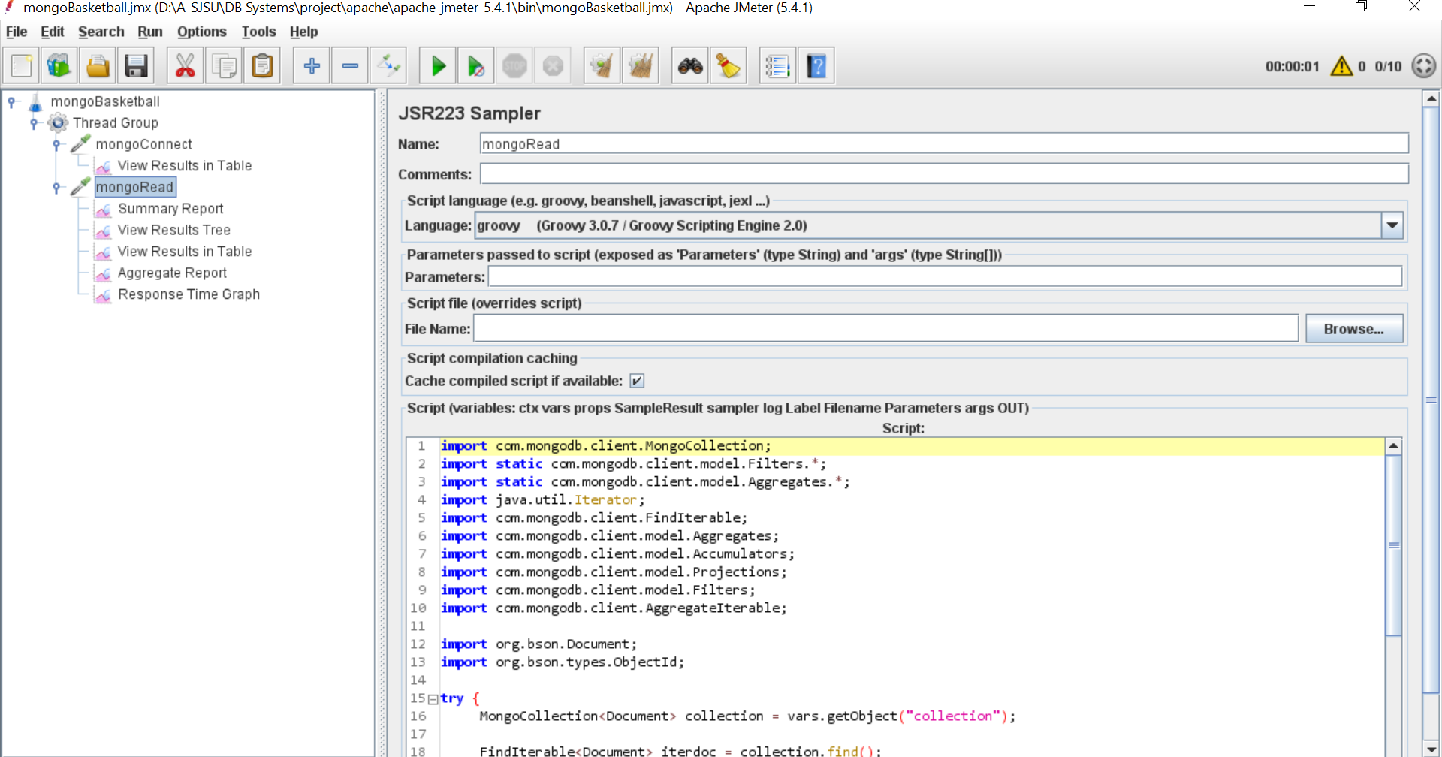

import com.mongodb.client.MongoCollection;

import static com.mongodb.client.model.Filters.*;

import static com.mongodb.client.model.Aggregates.*;

import java.util.Iterator;

import com.mongodb.client.FindIterable;

import com.mongodb.client.model.Aggregates;

import com.mongodb.client.model.Accumulators;

import com.mongodb.client.model.Projections;

import com.mongodb.client.model.Filters;

import com.mongodb.client.AggregateIterable;

import org.bson.Document;

import org.bson.types.ObjectId;

try {

MongoCollection<Document> collection = vars.getObject("collection");

FindIterable<Document> iterdoc = collection.find();

String result = "";

Iterator it = iterdoc.iterator();

while (it.hasNext()) {

result += it.next().get("TEAM_ID").toString();

result += '\n'

}

return result;

}

catch (Exception e) {

SampleResult.setSuccessful(false);

SampleResult.setResponseCode("500");

SampleResult.setResponseMessage("Exception: " + e);

}

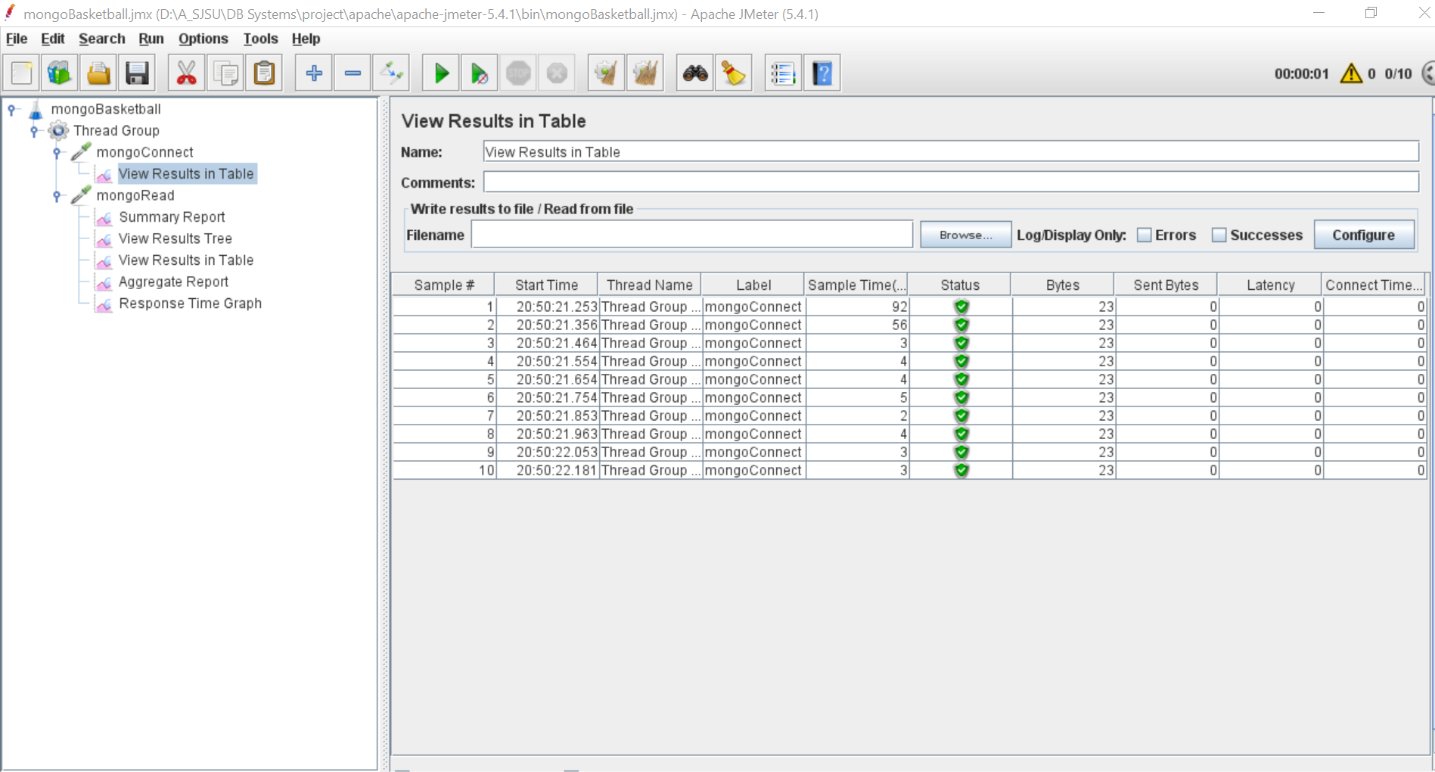

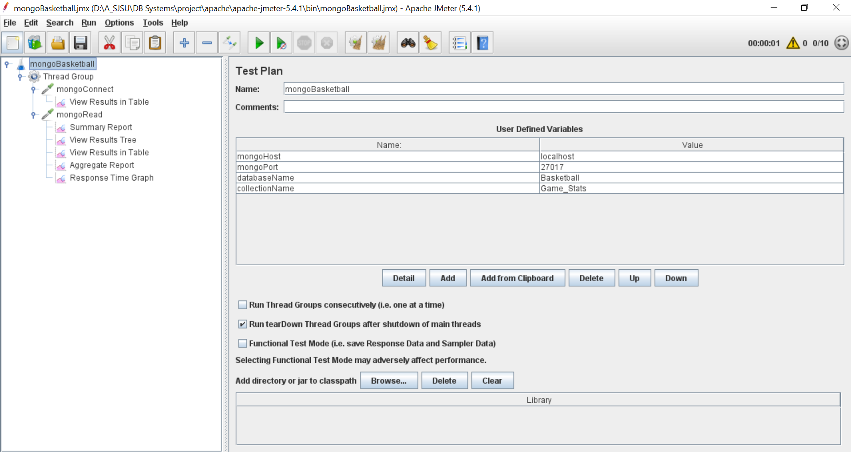

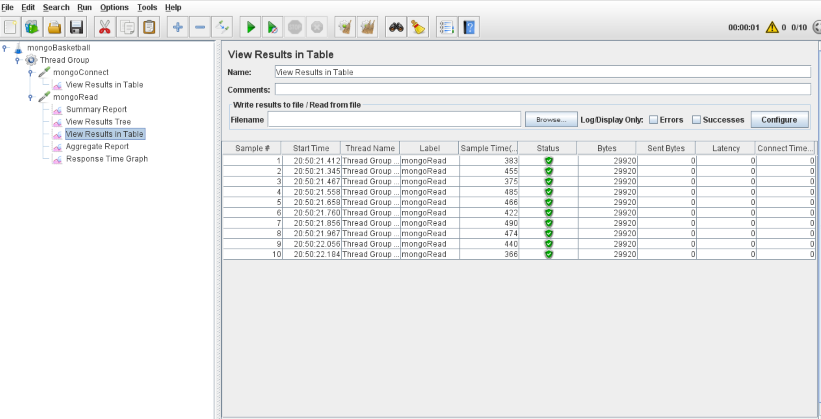

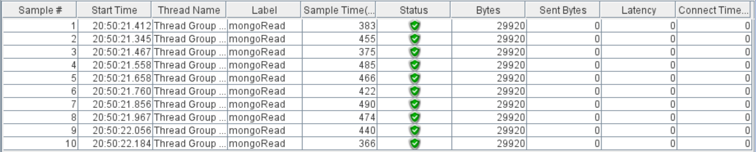

Player

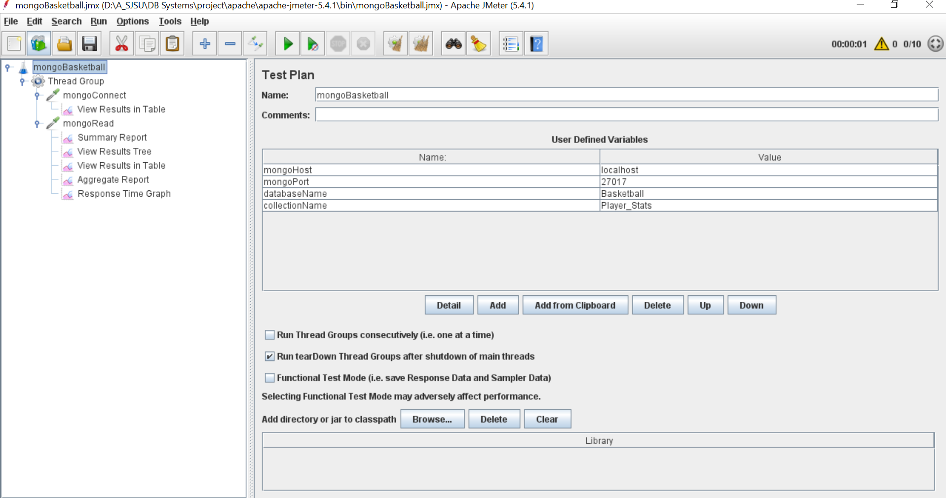

Connection

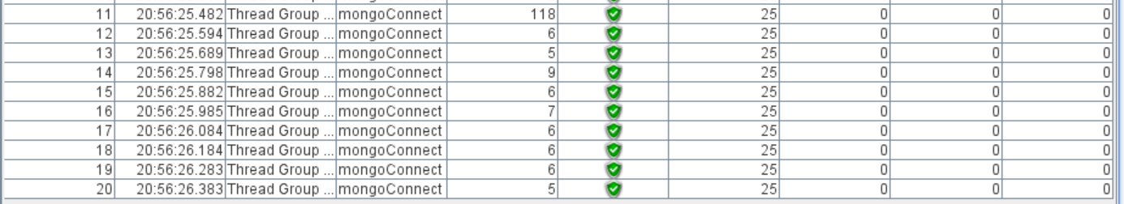

Query

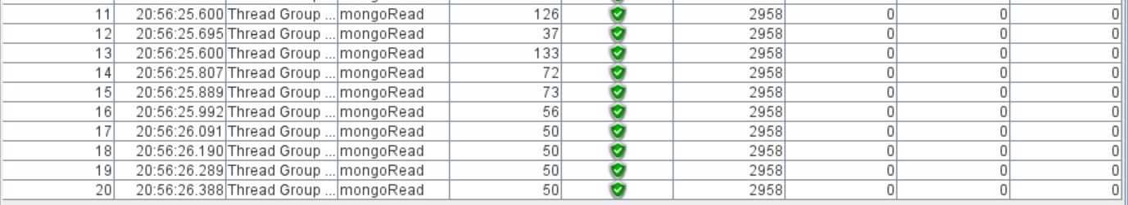

Team

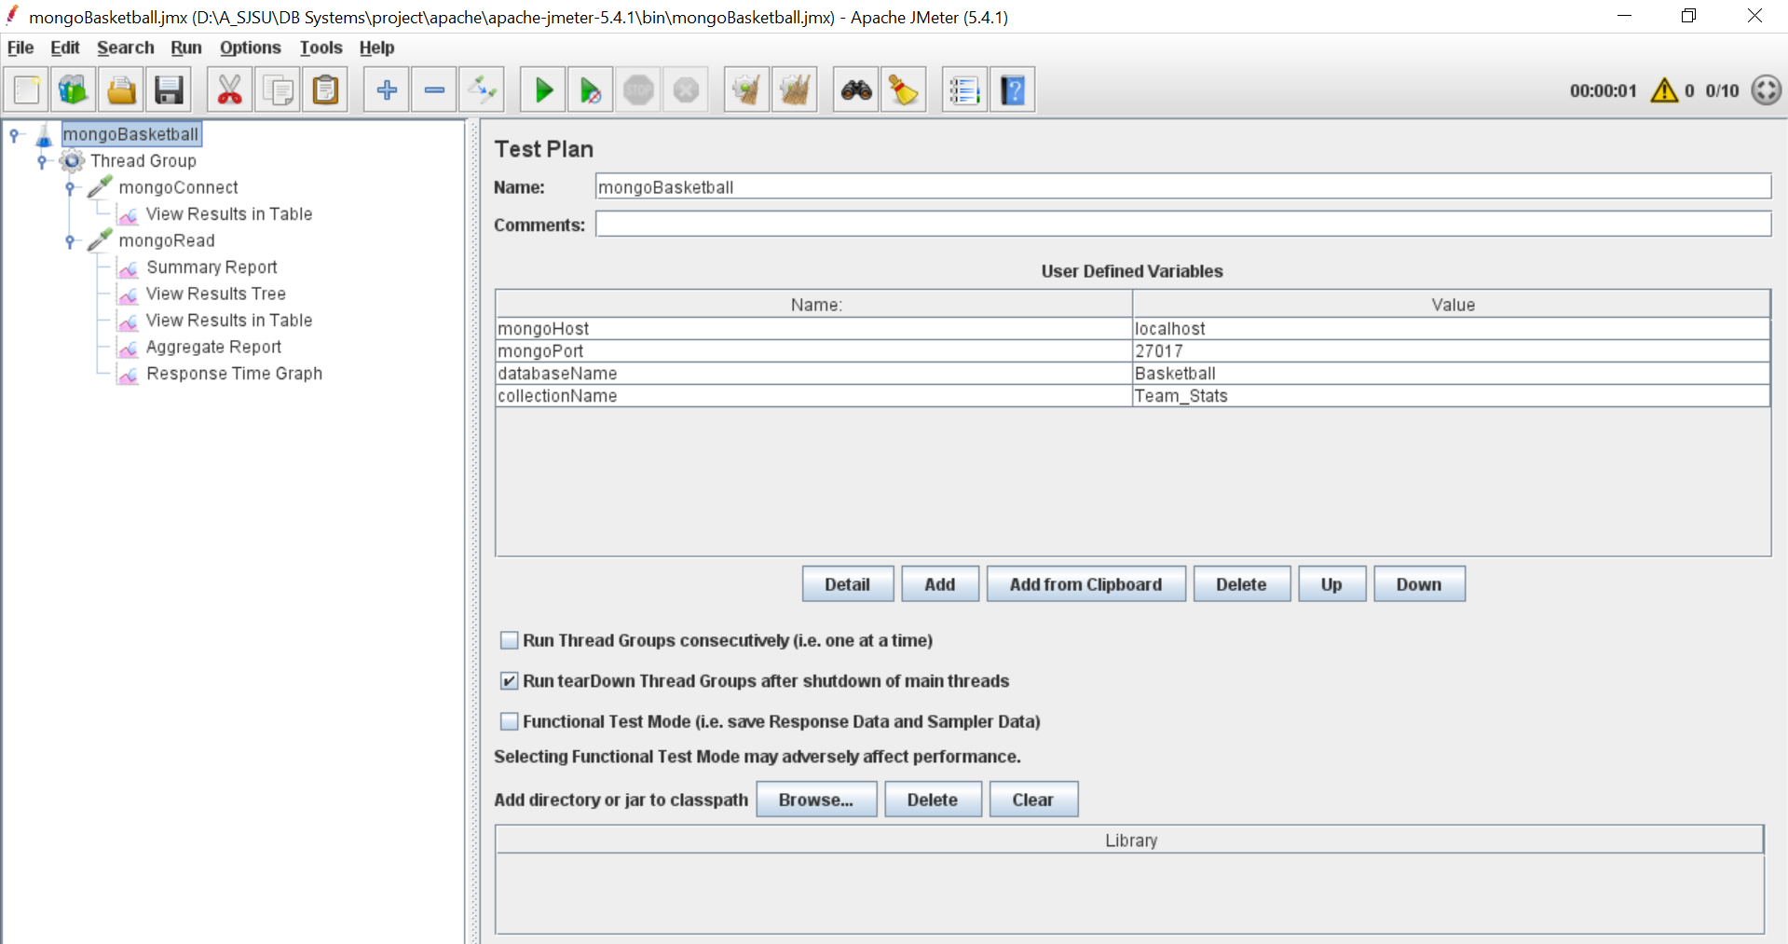

Connection

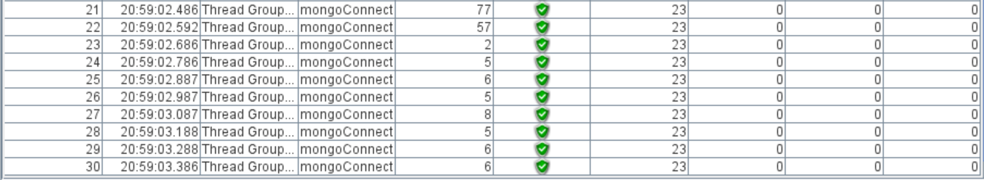

Query

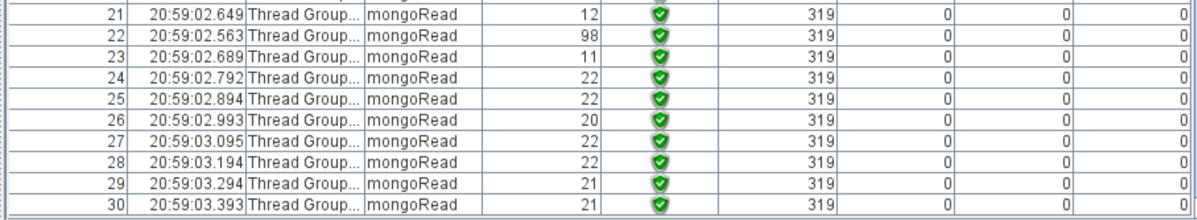

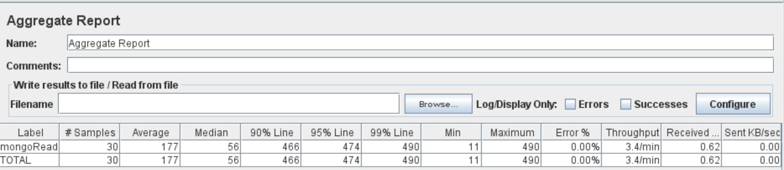

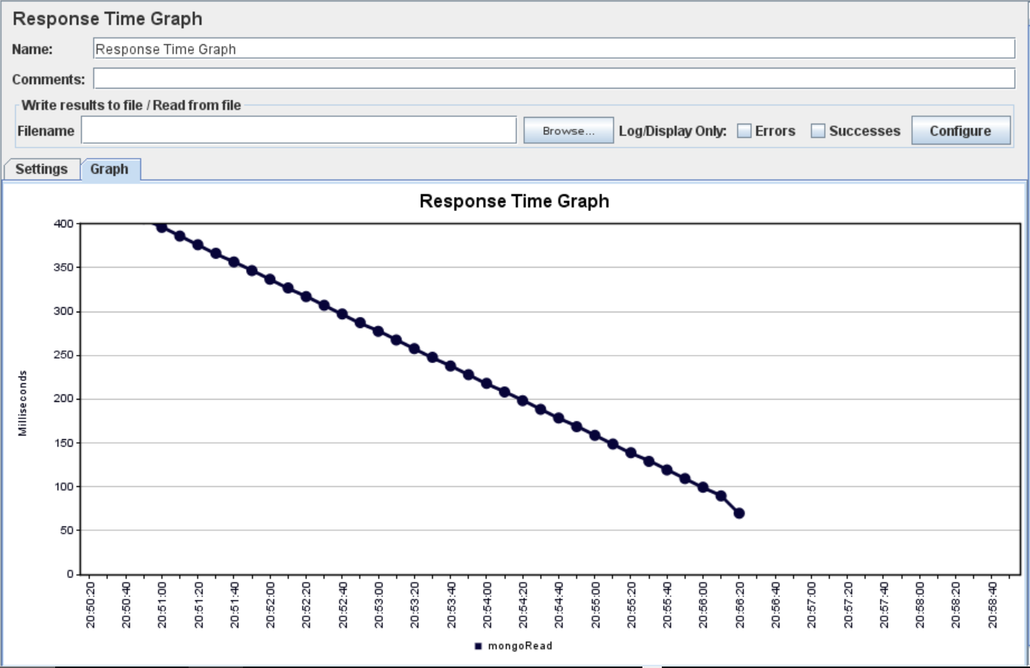

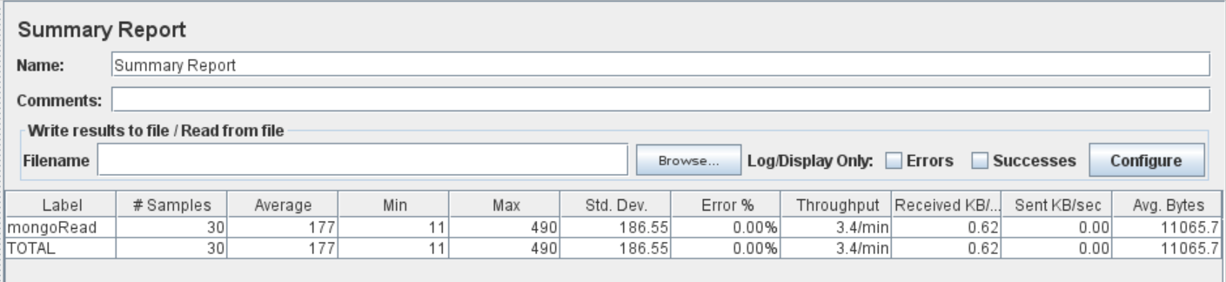

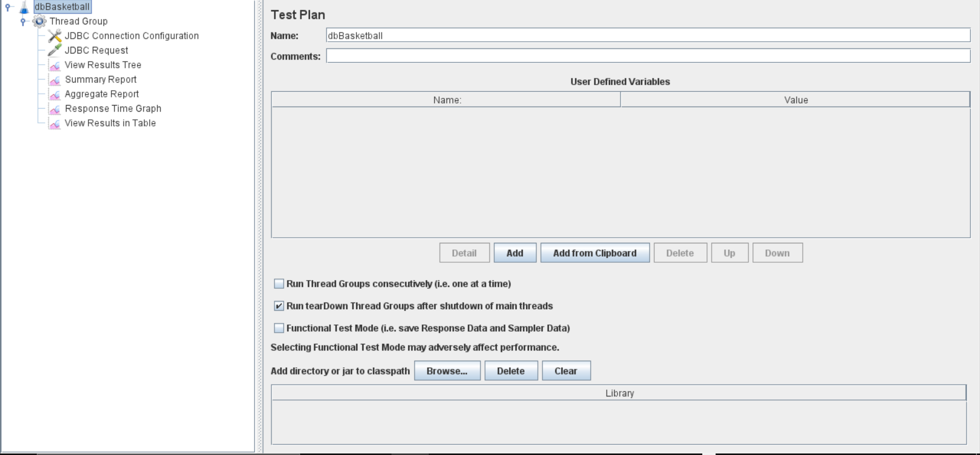

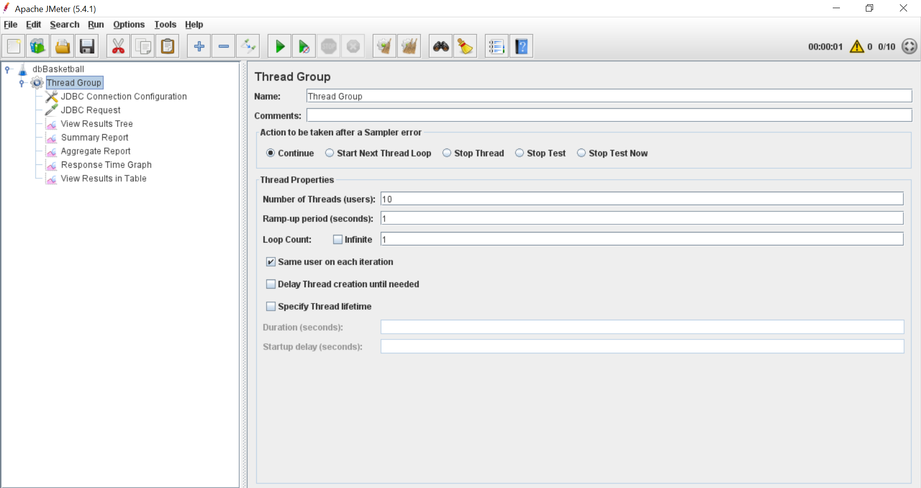

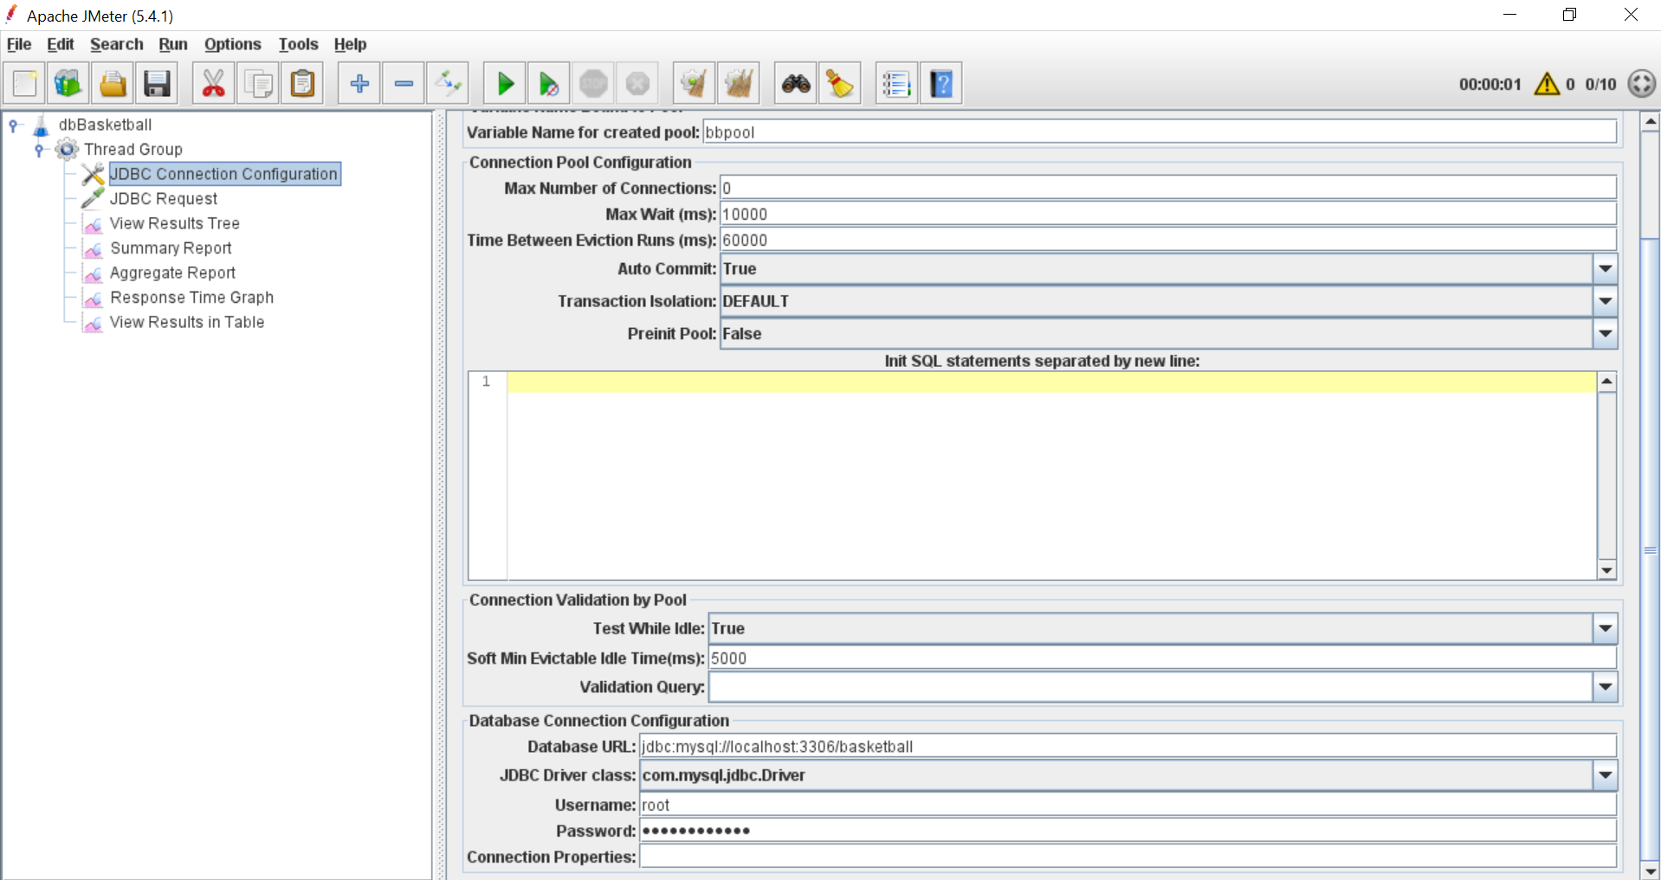

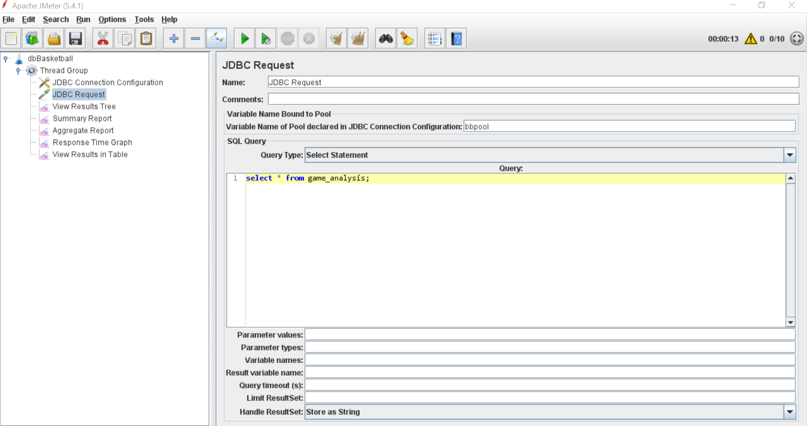

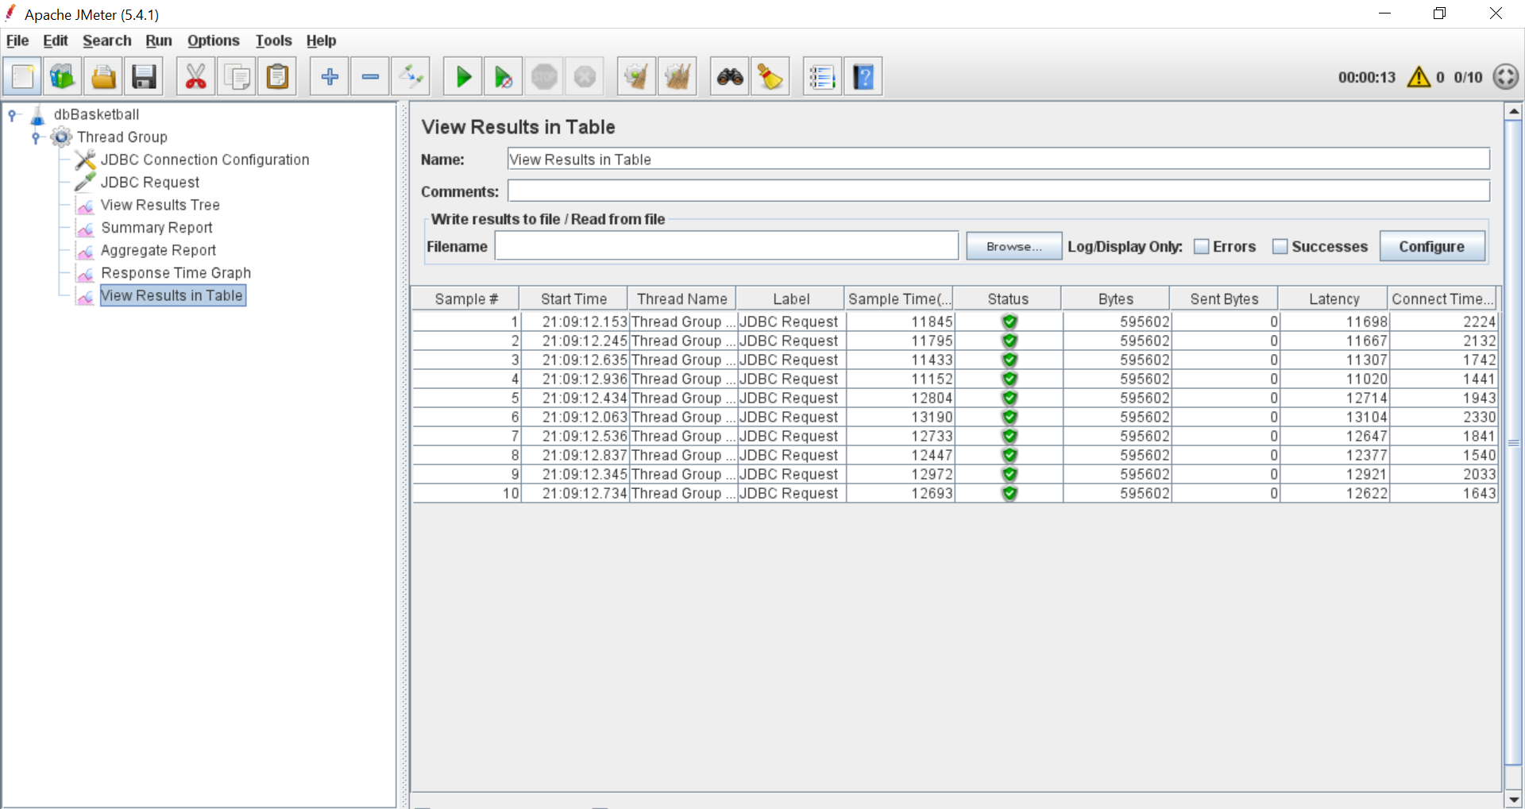

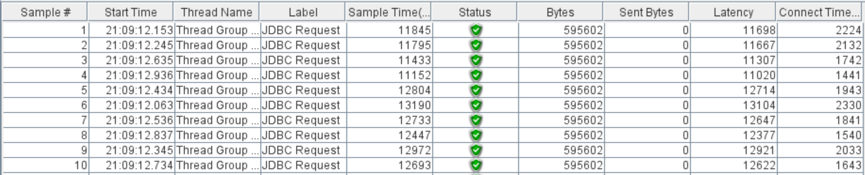

Player

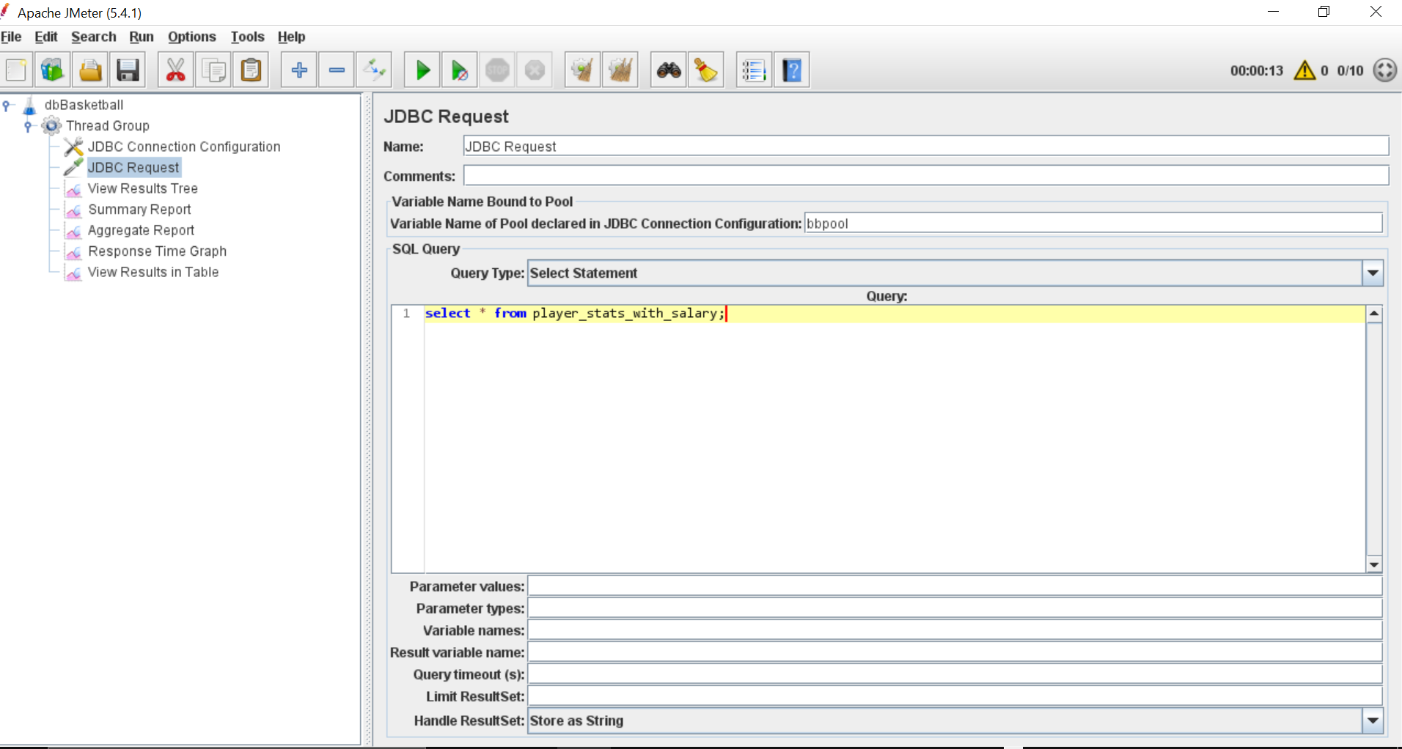

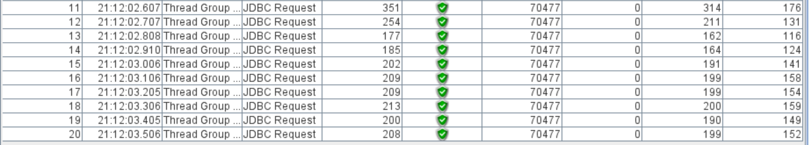

Team

